JAVA ASSIGNMENT-2

Question 1. Each customer of a bank has customer id, name, and current loan amount and phone number. One can change the attributes like name, phone number. A customer may ask for loan of certain amount. It is granted provided the sum of current loan amount and asked amount does not exceed credit limit (fixed amount for all customer). A customer may be a privileged amount. For such customers credit limit is higher. Once a loan is sanctioned necessary updates should be made. Any type of customer should be able to find his credit limit, current loan amount and amount of loan he can seek.
Design and implement the classes.
Solution:
Explanation:
Customer Class:
This class represents a generic customer. It has private fields such as customerid, customername, loanamount, and phonenumber.
It has setter methods (setid, setloan, setname, setphonenum) to set the values of customer attributes.
Getter methods (getloancurrent, getid) are provided to access customer information.
The displayinfo method prints basic customer information.
It has an updateloanamount method to update the loan amount for the customer.
NormalCustomer Class:
This class extends the Customer class, inheriting its attributes and methods.
It adds a creditlimit attribute specific to normal customers.
It overrides the getlimit and getavailableamount methods to provide credit limit and available loan amount specific to normal customers.
It also adds a method displaycurrentloaninfo to display current loan information specific to normal customers.
PriviledgedCustomer Class:
Similar to NormalCustomer, this class extends the Customer class and adds a creditlimit attribute specific to privileged customers.
It also overrides getlimit and getavailableamount methods, and adds displaycurrentloaninfo method for privileged customers.
MenuDriven Class:
This class handles the menu-driven interface for adding customers, updating loan amounts, and displaying customer information.
It maintains two ArrayLists, nc for normal customers and pc for privileged customers.
It provides methods to add customers (addnormalcustomer, addpriviledgedcustomer), check for unique customer IDs (checkuniquepc, checkuniquenc), display customer information (displaypc, displaync), and update loan amounts (updateloannc, updateloanpc).
The constructor initializes a Scanner for user input and presents a menu-driven interface to interact with the bank system

Code:
import java.util.ArrayList;
import java.util.Scanner;
class Customer
{
private int customerid;
private String customername;
private int loanamount=0;
private long phonenumber;

void setid(int cid)
{
customerid=cid;
}
void setloan(int n)
{
loanamount=n;
}
void setname(String cname)
{
customername=cname;
}
void setphonenum(long n)
{
phonenumber=n;
}
int getloancurrent()
{
return loanamount;
}
void updateloanamount(int n)
{
loanamount+=n;
}
int getid()
{
return customerid;
}
void displayinfo()
{
System.out.println("Customer ID: "+customerid);
System.out.println("Customer Name: "+customername);
System.out.println("Customer Phone Number: "+phonenumber);
}
}
class NormalCustomer extends Customer
{
final private int creditlimit=10000;
int getlimit()
{
return creditlimit;
}
int getavailableamount()
{
return creditlimit-getloancurrent();
}
void displaycurrentloaninfo()
{
System.out.println("Customer Current Loan: "+getloancurrent());
System.out.println("Customer Credit Limit: "+creditlimit);
System.out.println("Customer Available Amount: "+getavailableamount());
}
}
class PriviledgedCustomer extends Customer
{
final private int creditlimit=20000;
int getlimit()
{
return creditlimit;
}
int getavailableamount()
{
return creditlimit-getloancurrent();
}
void displaycurrentloaninfo()
{
System.out.println("Customer Current Loan: "+getloancurrent());
System.out.println("Customer Credit Limit: "+creditlimit);
System.out.println("Customer Available Amount: "+getavailableamount());
}
}
class MenuDriven
{
private ArrayList<PriviledgedCustomer> pc=new ArrayList<PriviledgedCustomer>();
private ArrayList<NormalCustomer> nc=new ArrayList<NormalCustomer>();

void addnormalcustomer(NormalCustomer c)
{
nc.add(c);
}
void addpriviledgedcustomer(PriviledgedCustomer c)
{
pc.add(c);
}
int checkuniquepc(int id)
{
for(int i=0;i<pc.size();i++)
{
if(id==pc.get(i).getid())
{
return 0;
}
}
return 1;
}
int checkuniquenc(int id)
{
for(int i=0;i<nc.size();i++)
{
if(id==nc.get(i).getid())
{
return 0;
}
}
return 1;
}
void displaypc(int id)
{
for(int i=0;i<pc.size();i++)
{
if(id==pc.get(i).getid())
{
pc.get(i).displayinfo();
pc.get(i).displaycurrentloaninfo();
return;
}
}
}
void displaync(int id)
{
for(int i=0;i<nc.size();i++)
{
if(id==nc.get(i).getid())
{
nc.get(i).displayinfo();
nc.get(i).displaycurrentloaninfo();
return;
}
}
}
void updateloannc(int id,int newloan)
{
for(int i=0;i<nc.size();i++)
{
if(id==nc.get(i).getid())
{
if(nc.get(i).getavailableamount()>=newloan)
nc.get(i).updateloanamount(newloan);
else
{
System.out.println("Loan amount exceeds limit.");
}
return;
}
}
}
void updateloanpc(int id,int newloan)
{
for(int i=0;i<pc.size();i++)
{
if(id==pc.get(i).getid())
{
if(pc.get(i).getavailableamount()>=newloan)
pc.get(i).updateloanamount(newloan);
else
{
System.out.println("Loan amount exceeds limit.");
}
return;
}
}
}
MenuDriven()
{
int ch;
int id;
String name;
long phonenum;
int loan;
Scanner sc=new Scanner(System.in);
while(true)
{
System.out.println("Enter 1 to add normal customer/Enter 2 to add priviledged customer/Enter 3 to avail loan/Enter 4 to diplay/Enter any other to exit: ");
ch=sc.nextInt();
sc.nextLine();
if(ch==1)
{
System.out.println("Enter Customer ID: ");
id=sc.nextInt();
sc.nextLine();
if(checkuniquenc(id)==1)
{
System.out.println("Enter Customer Name: ");
name=sc.nextLine();
System.out.println("Enter Customer Phone Number: ");
phonenum=sc.nextLong();
sc.nextLine();
NormalCustomer c=new NormalCustomer();
c.setid(id);
c.setname(name);
c.setphonenum(phonenum);
addnormalcustomer(c);
}
}
else if(ch==2)
{
System.out.println("Enter Customer ID: ");
id=sc.nextInt();
sc.nextLine();
if(checkuniquepc(id)==1)
{
System.out.println("Enter Customer Name: ");
name=sc.nextLine();
System.out.println("Enter Customer Phone Number: ");
phonenum=sc.nextLong();
sc.nextLine();
PriviledgedCustomer c=new PriviledgedCustomer();
c.setid(id);
c.setname(name);
c.setphonenum(phonenum);
addpriviledgedcustomer(c);
}
}
else if(ch==3)
{
System.out.println("Enter Customer ID: ");
id=sc.nextInt();
sc.nextLine();
System.out.println("Enter Customer Loan Amount: ");
loan=sc.nextInt();
sc.nextLine();
if(checkuniquenc(id)==0)
{
updateloannc(id, loan);
}
else if(checkuniquepc(id)==0)
{
updateloanpc(id, loan);
}
else
{
System.out.println("Customer not found.");
}
}
else if(ch==4)
{
System.out.println("Enter Customer ID: ");
id=sc.nextInt();
if(checkuniquenc(id)==0)
{
displaync(id);
}
else if(checkuniquepc(id)==0)
{
displaypc(id);
}
else
{
System.out.println("Customer not found.");
}
}
else
{
System.out.println("Exiting Bank.");
sc.close();
break;
}
}

}
}
class prog1
{
public static void main(String[] args) {
MenuDriven e=new MenuDriven();
}
}

Program Output:
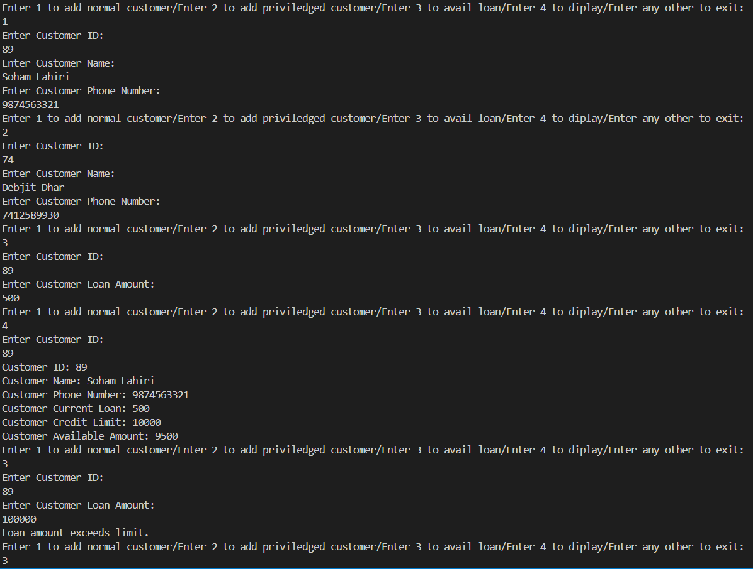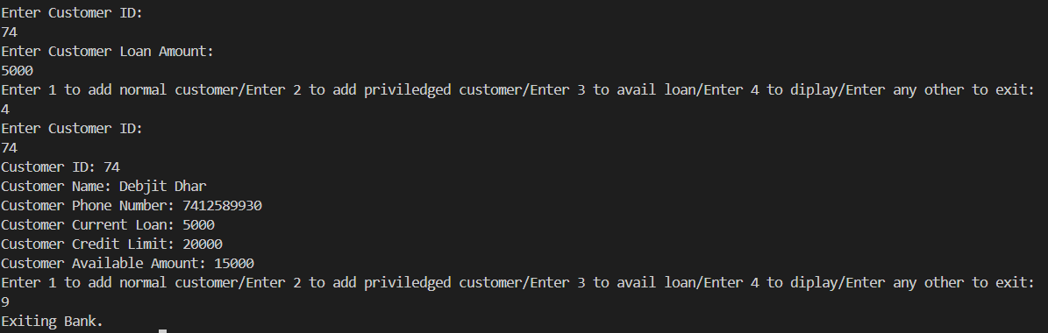

Question 2: For every person in an institute details like name, address (consists of premises number, street, city, pin and state), phone number, e-mail id are maintained. A person is either a student or a faculty. For student roll number and course of study are also be maintained. For faculty employee id, department and specialisation are to be stored. One should be able to view the object details and set the attributes. For address, one may change it partially depending on the choice. Design and implement the classes.

Explanation:

Person Class:
This class represents a generic person with attributes like name, street, city, state, pin code, phone number, email ID, and premise number.
It has methods to set data (setdata), display information (display), and change address (changeaddress).

Student Class:
This class extends the Person class and adds attributes specific to students such as course and roll number.
It has methods to set student data (setstudentdata), display student information (displaystudent), and get the roll number (getrollnumber).

Faculty Class:
Similar to the Student class, this class extends the Person class and adds attributes specific to faculty members such as employee ID, department, and specialization.
It has methods to set faculty data (setfacultydata), display faculty information (displayfaculty), and get the employee ID (getemployeeid).

PersonList Class:
This class manages lists of students and faculty members.
It has ArrayLists to store instances of Student and Faculty.
Methods like checkstudentunique and checkfacultyunique are provided to check for uniqueness of roll numbers and employee IDs.
The constructor handles user input to add students or faculty, display their details, and change their addresses

Code:
import java.util.ArrayList;
import java.util.Scanner;
class Person
{
private String name;
private String street;
private String city ;
private String state;
private String pin;
private long phonenumber;
private String emailid;
private String premisesNumber;

void setdata(String n, String st, String ci, String s, String p, long pn, String eid, String pri)
{
name=n;
street=st;
city=ci;
state=s;
pin=p;
phonenumber=pn;
emailid=eid;
premisesNumber=pri;
}
void display()
{
System.out.println("Name: "+name);
System.out.println("Premise Number: "+premisesNumber);
System.out.println("Street: "+street);
System.out.println("City: "+city);
System.out.println("Pin: "+pin);
System.out.println("State: "+state);
System.out.println("Phone number: "+phonenumber);
System.out.println("Email-ID: "+emailid);
}

void changeaddress(String n,int c)
{
if(c==1)
{
street=n;
}
else if(c==2)
{
city=n;
}
else if(c==3)
{
state=n;
}
else if(c==4)
{
pin=n;
}
else if(c==5)
{
premisesNumber=n;
}
}
}
class Student extends Person
{
private String course;
private int rollNumber;

void setstudentdata(String c, int r)
{
course=c;
rollNumber=r;
}
void displaystudent()
{
super.display();
System.out.println("Roll Number: "+rollNumber);
System.out.println("Course: "+course);
}
int getrollnumber()
{
return rollNumber;
}

class Faculty extends Person
{
private int employeeid;
private String department;
private String specialisation;
void setfacultydata(int eid, String d, String sp)
{
employeeid=eid;
department=d;
specialisation=sp;
}
void displayfaculty()
{
super.display();
System.out.println("Employee ID: "+employeeid);
System.out.println("Department: "+department);
System.out.println("Specialisation: "+specialisation);
}
int getemployeeid()
{
return employeeid;
}
}
class PersonList
{
ArrayList<Student> stulist=new ArrayList<Student>();
ArrayList<Faculty> faclist=new ArrayList<Faculty>();

int checkstudentunique(int r)
{
for(int i=0;i<stulist.size();i++)
{
if(r==stulist.get(i).getrollnumber())
{
return i;
}
}
return -1;
}
int checkfacultyunique(int eid)
{
for(int i=0;i<faclist.size();i++)
{
if(eid==faclist.get(i).getemployeeid())
{
return i;
}
}
return -1;
}
PersonList()
{
String n,st,ci,s,p,eid,pri,c,dept,spec;
int rn,empid;
long pn;
int ch;
Student stu=new Student();
Faculty fac=new Faculty();
Scanner sc=new Scanner(System.in);
while(true)
{
System.out.println("Enter 1 to add student/Enter 2 to add faculty/Enter 3 to display student details/Enter 4 to display faculty details/Enter 5 to change address of student/Enter 6 to change address of faculty/Enter any other to exit: ");
ch=sc.nextInt();
if(ch==1)
{
System.out.println("Enter Roll Number: ");
rn=sc.nextInt();
if(checkstudentunique(rn)!=-1)
{
System.out.println("Student Roll Number exists");
}
else
{
sc.nextLine();
System.out.println("Enter Student Name: ");
n=sc.nextLine();
System.out.println("Enter Street: ");
st=sc.nextLine();
System.out.println("Enter City: ");
ci=sc.nextLine();
System.out.println("Enter State: ");
s=sc.nextLine();
System.out.println("Enter Pin: ");
p=sc.nextLine();
System.out.println("Enter Phone Number: ");
pn=sc.nextLong();
sc.nextLine();
System.out.println("Enter Email-ID: ");
eid=sc.nextLine();
System.out.println("Enter Premise Number: ");
pri=sc.nextLine();
System.out.println("Enter Course Name");
c=sc.nextLine();
stu.setdata(n,st,ci,s,p,pn,eid,pri);
stu.setstudentdata(c,rn);
stulist.add(stu);
System.out.println("Student Added");
}
}
else if(ch==2)
{
System.out.println("Enter Employee ID: ");
empid=sc.nextInt();
if(checkfacultyunique(empid)!=-1)
{
System.out.println("Employee ID exists");
}
else
{
sc.nextLine();
System.out.println("Enter Faculty Name: ");
n=sc.nextLine();
System.out.println("Enter Street: ");
st=sc.nextLine();
System.out.println("Enter City: ");
ci=sc.nextLine();
System.out.println("Enter State: ");
s=sc.nextLine();
System.out.println("Enter Pin: ");
p=sc.nextLine();
System.out.println("Enter Phone Number: ");
pn=sc.nextLong();
sc.nextLine();
System.out.println("Enter Email-ID: ");
eid=sc.nextLine();
System.out.println("Enter Premise Number: ");
pri=sc.nextLine();
System.out.println("Enter Department: ");
dept=sc.nextLine();
System.out.println("Enter Specialisation: ");
spec=sc.nextLine();
fac.setdata(n, st, ci, s, p, pn, eid, pri);
fac.setfacultydata(empid,dept,spec);
faclist.add(fac);
System.out.println("Faculty Added");
}
}
else if(ch==3)
{
System.out.println("Enter Roll Number: ");
rn=sc.nextInt();
if(checkstudentunique(rn)==-1)
{
System.out.println("Roll Number does not exist");
}
else
stulist.get(checkstudentunique(rn)).displaystudent();
}
else if(ch==4)
{
System.out.println("Enter EmployeeId: ");
empid=sc.nextInt();
if(checkfacultyunique(empid)==-1)
{
System.out.println("Employee ID does not exist");
}
else
faclist.get(checkfacultyunique(empid)).displayfaculty();
}
else if(ch==5)
{
System.out.println("Enter Roll Number: ");
rn=sc.nextInt();
int i=checkstudentunique(rn);
if(i==-1)
{
System.out.println("Roll Number does not exist");
}
else
{
while(true)
{
int ch2;
System.out.println("Enter 1 to change street/Enter 2 to change city/Enter 3 to change state/Enter 4 to change pin/Enter 5 to change premise number/Enter any other to exit: ");
ch2=sc.nextInt();
sc.nextLine();
if(ch2==1)
{
System.out.println("Enter Street: ");
st=sc.nextLine();
stulist.get(i).changeaddress(st,1);
}
else if(ch2==2)
{
System.out.println("Enter City: ");
ci=sc.nextLine();
stulist.get(i).changeaddress(ci,2);
}
else if(ch2==3)
{
System.out.println("Enter State: ");
s=sc.nextLine();
stulist.get(i).changeaddress(s,3);
}
else if(ch2==4)
{
System.out.println("Enter Pin: ");
p=sc.nextLine();
stulist.get(i).changeaddress(p,4);
}
else if(ch2==5)
{
System.out.println("Enter Premise Number: ");
pri=sc.nextLine();
stulist.get(i).changeaddress(pri,5);
}
else
break;
}
}
}
else if(ch==6)
{
System.out.println("Enter Employee ID: ");
empid=sc.nextInt();
int i=checkfacultyunique(empid);
if(i==-1)
{
System.out.println("Employee ID does not exist");
}
else
{
while(true)
{
int ch2;
System.out.println("Enter 1 to change street/Enter 2 to change city/Enter 3 to change state/Enter 4 to change pin/Enter 5 to change premise number/Enter any other to exit: ");
ch2=sc.nextInt();
sc.nextLine();
if(ch2==1)
{
System.out.println("Enter Street: ");
st=sc.nextLine();
faclist.get(i).changeaddress(st,1);
}
else if(ch2==2)
{
System.out.println("Enter City: ");
ci=sc.nextLine();
faclist.get(i).changeaddress(ci,2);
}
else if(ch2==3)
{
System.out.println("Enter State: ");
s=sc.nextLine();
faclist.get(i).changeaddress(s,3);
}
else if(ch2==4)
{
System.out.println("Enter Pin: ");
p=sc.nextLine();
faclist.get(i).changeaddress(p,4);
}
else if(ch2==5)
{
System.out.println("Enter Premise Number: ");
pri=sc.nextLine();
faclist.get(i).changeaddress(pri,5);
}
else
break;
}
}
}
else
{
sc.close();
break;
}
}
}
}
class StudentFacultySystem
{
public static void main(String args[])
{
PersonList p=new PersonList();
}
}

Program Output:
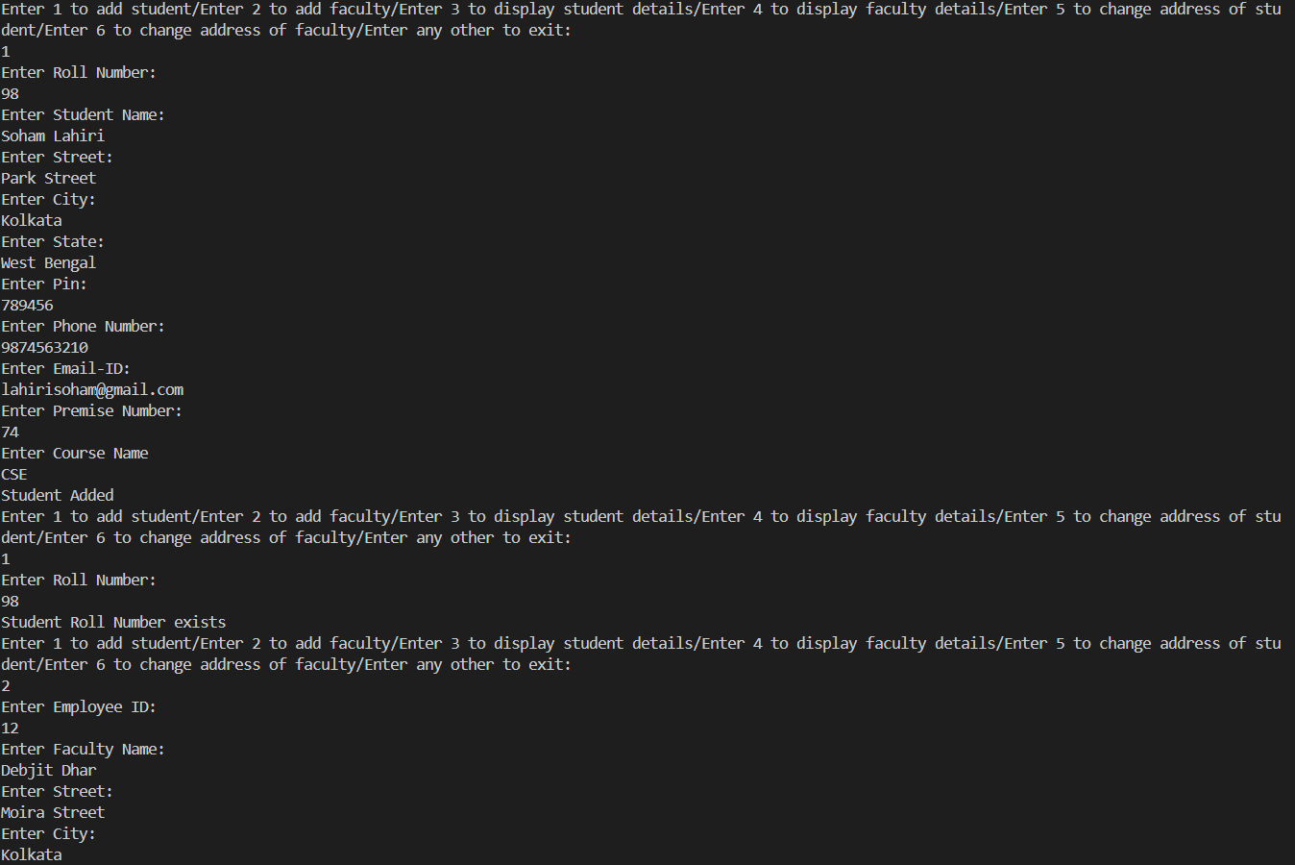

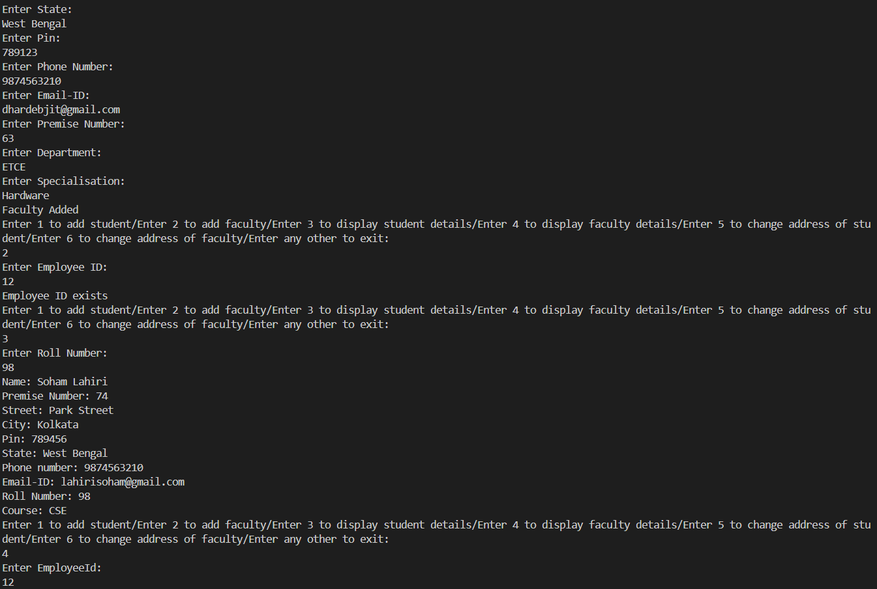

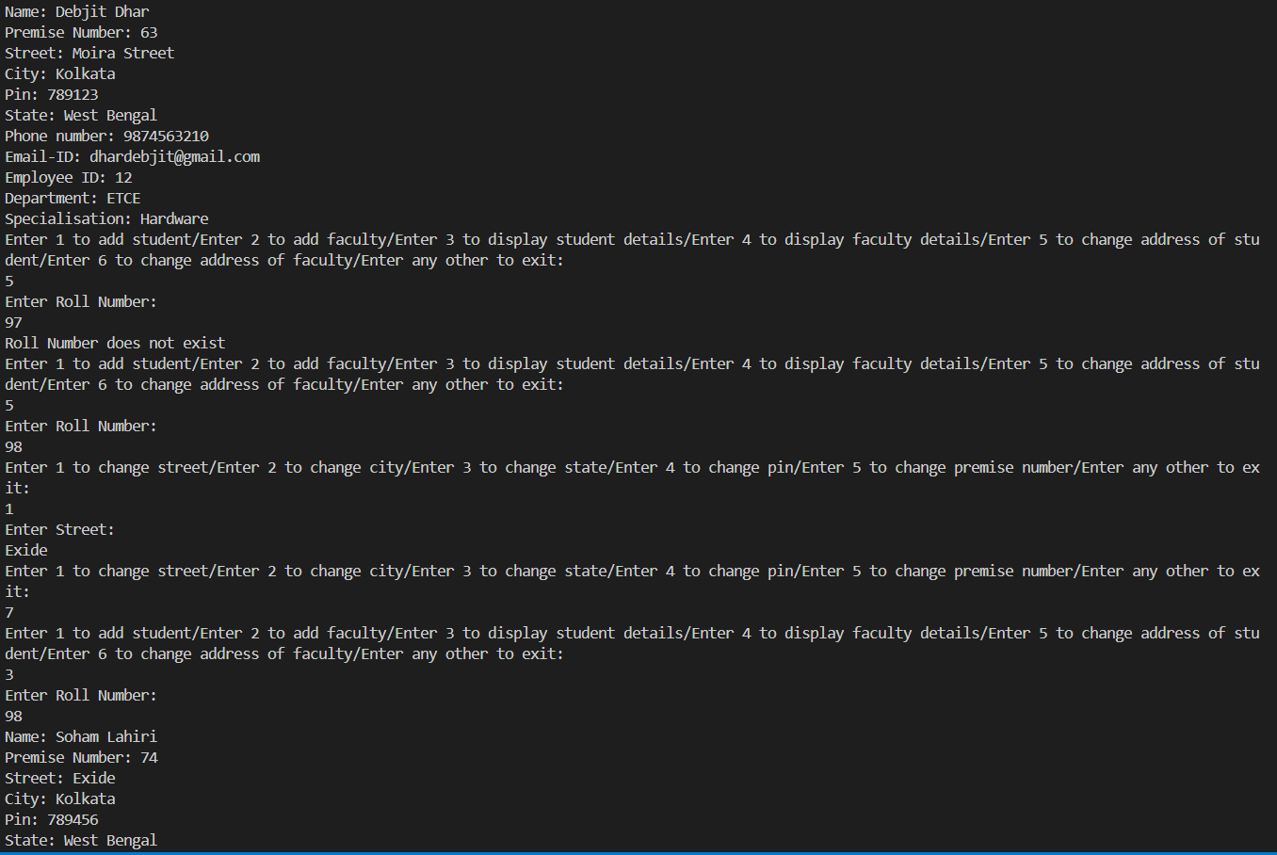

Question 3. For a library management system design BookList, MemberList and Transaction packages. Booklist package will have the support to store book information in the list like book id, title, total number of copies purchased, and number of copies currently available. One can add book in list (verifying uniqueness of book id), change the attribute values (particularly, increase/decrease copies purchased, available as and when required), display particular book information (for a book id) and also total list. MemberList package will provide the service for maintaining member information. Member information includes member id (unique), name, date of birth and number of books currently issued to him. There is a limit on number of books one can have at a point of time (it is same for all members). Transaction package maintains a list of transaction. A transaction entry in the list keeps member id, book id of the book being issued. Supports are to be provided to modify the entries. An entry with member id ‘xxxx’ can be used for adding a new entry.
Using the packages, develop a system that can do the following:
i) Add new book in booklist ii) Add more copies for a book iii) Show all book details iv) Show details of a book v) Add member in the list vi) show all members vii) show details of a member viii) Issue a book ( check book validity and availability, check member validity and eligibility to get a book, once passes through the validations add an entry into transaction list and update counts in corresponding booklist and memberlist entries) ix) book return book ( check the validity of corresponding issue with book id and member id and once passes through the validations update the transaction entry by marking member id as ‘xxxx’ and update counts in corresponding booklist and memberlist entries)
Consider the list as arrays. While working with arrays it is to be ensured that use of indices out of the range is reported.
Explanation:
BookList Package:
BookInfo Class:
Manages information about books such as book ID, title, availability, and number of copies.
Provides methods to set book data, display book information, issue a book, return a book, and check if a book is eligible for issuing.
BookInfoList Class:
Manages a list of books (ArrayList<BookInfo>).
Provides methods to check for unique book IDs, add a new book, display all books, add more copies of a book, display details of a specific book, issue a book, return a book, and check if a book is eligible for issuing.
MemberList Package:
MemberInfo Class:
Manages information about members such as member ID, name, date of birth, and number of books.
Provides methods to set member data, display member information, add a book to a member, remove a book from a member, and check if a member is eligible for issuing books.
MemberInfoList Class:
Manages a list of members (ArrayList<MemberInfo>).
Provides methods to check for unique member IDs, add a new member, display all members, display details of a specific member, issue a book to a member, return a book from a member, and check if a member is eligible for issuing books.
TransactionList Package:
TransactionInfo Class:
Manages information about transactions such as member ID and book ID.
Provides methods to set transaction data, display transaction information, get book ID, get member ID, and mark a returned book.
TransactionInfoList Class:
Manages a list of transactions (ArrayList<TransactionInfo>).
Provides methods to check for unique combinations of member ID and book ID, add a new transaction, display all transactions, and remove a transaction when a book is returned.
Main Program:
BookSystem Class:
Integrates functionalities from the BookList, MemberList, and TransactionList packages to create a book management system.
Provides a menu-driven interface for users to add books, add members, issue/return books, and display information.
Uses objects of BookInfoList, MemberInfoList, and TransactionInfoList to manage books, members, and transactions respectively.
Code:
BookList package:
package BookList;

import java.util.ArrayList;
class BookInfo
{
private long bookId;
private String booktitle;
private int avail;
private int numberofbooks;

void setdata(String t,long Id,int n)
{
booktitle=t;
bookId=Id;
avail=n;
numberofbooks=n;
}
void displayinfo()
{
System.out.println("Book Id: "+bookId);
System.out.println("Book Title: "+booktitle);
System.out.println("Available number of books: "+avail);
System.out.println("Number of copies of books purchased: "+numberofbooks);
}
void issuebook()
{
avail--;
}
void returnbook()
{
avail++;
}
int checkeligible()
{
if(avail>0)
return 1;
else
return 0;
}
long getbookId()
{
return bookId;
}
void changenumberofbooks(int n)
{
numberofbooks+=n;
avail+=n;
}
}

public class BookInfoList
{
ArrayList<BookInfo> books=new ArrayList<BookInfo>();
public int checkbookunique(long id)
{
for(int i=0;i<books.size();i++)
{
if(id==books.get(i).getbookId())
return i;
}
return -1;
}

public void addBook(String t,long Id,int n)
{
BookInfo book=new BookInfo();
book.setdata(t,Id,n);
books.add(book);
}
public void displaybooks()
{
for(int i=0;i<books.size();i++)
{
books.get(i).displayinfo();
}
}
public void addbookcopies(long id,int n)
{
for(int i=0;i<books.size();i++)
{
if(id==books.get(i).getbookId())
books.get(i).changenumberofbooks(n);
}
}
public void displaypbook(long id)
{
for(int i=0;i<books.size();i++)
{
if(id==books.get(i).getbookId())
{
books.get(i).displayinfo();
}
}
}
public void issueBookl(long id)
{
for(int i=0;i<books.size();i++)
{
if(id==books.get(i).getbookId())
{
books.get(i).issuebook();;
}
}
}
public void returnBookl(long id)
{
for(int i=0;i<books.size();i++)
{
if(id==books.get(i).getbookId())
{
books.get(i).returnbook();
}
}
}
public int checkbookeligible(long id)
{
for(int i=0;i<books.size();i++)
{
if(id==books.get(i).getbookId())
{
return books.get(i).checkeligible();
}
}
return 0;
}
}

MemberList Package:
package MemberList;
import java.util.ArrayList;
class MemberInfo
{
private long memberId;
private String membername;
private String dateofbirth;
private int numberofbooks;
final private int limit=5;

void setdata(String name, String dob,long id)
{
membername=name;
dateofbirth=dob;
memberId=id;
numberofbooks=0;
}
void displayinfo()
{
System.out.println("Member Id: "+memberId);
System.out.println("Member Name: "+membername);
System.out.println("Date of Birth: "+dateofbirth);
System.out.println("Number of Books: "+numberofbooks);
System.out.println("Maximum Number of Books: "+limit);
}
void addbook()
{
numberofbooks++;
}
void removebook()
{
numberofbooks--;
}
int checkeligible()
{
if(numberofbooks<limit)
return 1;
else
return 0;
}
long getmemberId()
{
return memberId;
}
}

public class MemberInfoList
{
ArrayList<MemberInfo> members=new ArrayList<MemberInfo>();

public int checkmemberunique(long id)
{
for(int i=0;i<members.size();i++)
{
if(id==members.get(i).getmemberId())
{
return i;
}
}
return -1;
}
public void addmember(String name, String dob,long id)
{
MemberInfo member=new MemberInfo();
member.setdata(name,dob,id);
members.add(member);
}
public void displaymembers()
{
for(int i=0;i<members.size();i++)
{
members.get(i).displayinfo();
}
}
public void displaymember(long mid)
{
for(int i=0;i<members.size();i++)
{
if(mid==members.get(i).getmemberId())
{
members.get(i).displayinfo();
}
}
}
public void issuebookmember(long mid)
{
for(int i=0;i<members.size();i++)
{
if(mid==members.get(i).getmemberId())
{
members.get(i).addbook();
}
}
}
public void returnbookmember(long mid)
{
for(int i=0;i<members.size();i++)
{
if(mid==members.get(i).getmemberId())
{
members.get(i).removebook();
}
}
}
public int checkeligiblemember(long mid)
{
for(int i=0;i<members.size();i++)
{
if(mid==members.get(i).getmemberId())
{
return members.get(i).checkeligible();
}
}
return 0;
}
}

TransactionList Package:

package TransactionList;
import java.util.ArrayList;

class TransactionInfo
{
private long memberId;
private long bookId;
void setdata(long bid,long mid)
{
bookId=bid;
memberId=mid;
}
void displayinfo()
{
System.out.println("Member Id: " + memberId);
System.out.println("Book Id: " + bookId);
}
long getbookId()
{
return bookId;
}
long getmemberId()
{
return memberId;
}
void returnbookmember()
{
memberId = -99999;
}
}

public class TransactionInfoList
{
ArrayList<TransactionInfo> transactions=new ArrayList<TransactionInfo>();

public int checkmemberbookunique(long mid,long bid)
{
for(int i=0;i<transactions.size();i++)
{
if(mid==transactions.get(i).getmemberId() && bid==transactions.get(i).getbookId())
{
return i;
}
}
return -1;
}
public void addtransaction(long bid, long mid)
{
TransactionInfo transaction=new TransactionInfo();
transaction.setdata(bid,mid);
transactions.add(transaction);
}
public void displaytransactions()
{
for(int i=0;i<transactions.size();i++)
{
transactions.get(i).displayinfo();
}
}
public void removetransactions(long mid,long bid)
{
int index=checkmemberbookunique(mid,bid);
if(index!=-1)
{
transactions.get(index).returnbookmember();
}
}
}

Main Program:
import BookList.BookInfoList;
import MemberList.MemberInfoList;
import TransactionList.TransactionInfoList;
import java.util.Scanner;
class BookSystem
{
BookInfoList booklist=new BookInfoList();
MemberInfoList memberlist=new MemberInfoList();
TransactionInfoList transactionlist=new TransactionInfoList();
BookSystem()
{
System.out.println("Welcome to Book System");
long bid,mid;
int av,nob;
String bt,mn,dob;
Scanner sc=new Scanner(System.in);
int ch;
while(true)
{
System.out.println("Enter 1 to add new book/Enter 2 to add more copies/Enter 3 to display all books/Enter 4 to display details of a book/Enter 5 to add member/Enter 6 to display all members/Enter 7 to display details of a member/Enter 8 to issue a book/Enter 9 to return a book/Enter 10 to display all transactions/Enter any other to exit: ");
ch=sc.nextInt();
sc.nextLine();
if(ch==1)
{
System.out.println("Enter Book ID: ");
bid=sc.nextLong();
sc.nextLine();
if(booklist.checkbookunique(bid)==-1)
{
System.out.println("Enter Book Title: ");
bt=sc.nextLine();
System.out.println("Enter Number of Copies: ");
nob=sc.nextInt();
sc.nextLine();
booklist.addBook(bt,bid,nob);
}
else
System.out.println("Book ID already exists");
}
else if(ch==2)
{
System.out.println("Enter Book ID: ");
bid=sc.nextLong();
sc.nextLine();
if(booklist.checkbookunique(bid)!=-1)
{
System.out.println("Enter extra copies to be added: ");
av=sc.nextInt();
sc.nextLine();
booklist.addbookcopies(bid,av);
}
else
System.out.println("Book ID does not exist");
}
else if(ch==3)
{
booklist.displaybooks();
}
else if(ch==4)
{
System.out.println("Enter Book ID: ");
bid=sc.nextLong();
sc.nextLine();
if(booklist.checkbookunique(bid)!=-1)
{
booklist.displaypbook(bid);
}
else
System.out.println("Book ID does not exist");
}
else if(ch==5)
{
System.out.println("Enter Member ID: ");
mid=sc.nextLong();
sc.nextLine();
if(memberlist.checkmemberunique(mid)==-1)
{
System.out.println("Enter Member Name: ");
mn=sc.nextLine();
System.out.println("Enter Date of Birth: ");
dob=sc.nextLine();
memberlist.addmember(mn,dob,mid);
}
else
System.out.println("Member ID already exists");
}
else if(ch==6)
{
memberlist.displaymembers();
}
else if(ch==7)
{
System.out.println("Enter Member ID: ");
mid=sc.nextLong();
sc.nextLine();
if(memberlist.checkmemberunique(mid)!=-1)
{
memberlist.displaymember(mid);
}
else
System.out.println("Member ID does not exist");
}
else if(ch==8)
{
System.out.println("Enter Member ID: ");
mid=sc.nextLong();
sc.nextLine();
if(memberlist.checkmemberunique(mid)!=-1)
{
if(memberlist.checkeligiblemember(mid)==0)
System.out.println("Member already has maximum number of books.");
else
{
System.out.println("Enter Book ID: ");
bid=sc.nextLong();
sc.nextLine();
if(booklist.checkbookunique(bid)!=-1)
{
if(booklist.checkbookeligible(bid)==0)
System.out.println("No book copies available.");
else
{
transactionlist.addtransaction(bid,mid);
booklist.issueBookl(bid);
memberlist.issuebookmember(mid);
}
}
else
System.out.println("Book ID does not exist");
}
}
else
System.out.println("Member ID does not exist");
}
else if(ch==9)
{
System.out.println("Enter Member ID: ");
mid=sc.nextLong();
sc.nextLine();
if(memberlist.checkmemberunique(mid)!=-1)
{
System.out.println("Enter Book ID: ");
bid=sc.nextLong();
sc.nextLine();
if(booklist.checkbookunique(bid)!=-1)
{
if(transactionlist.checkmemberbookunique(mid,bid)!=-1)
{
transactionlist.removetransactions(mid,bid);
booklist.returnBookl(bid);
memberlist.returnbookmember(mid);
}
else
System.out.println("Book not issued to this member.");
}
else
System.out.println("Book ID does not exist");
}
else
System.out.println("Member ID does not exist");
}
else if(ch==10)
transactionlist.displaytransactions();
else
{
sc.close();
break;
}
}
}
}

class MainSystem
{
public static void main(String[] args)
{
BookSystem bs=new BookSystem();
}}

Program Output:
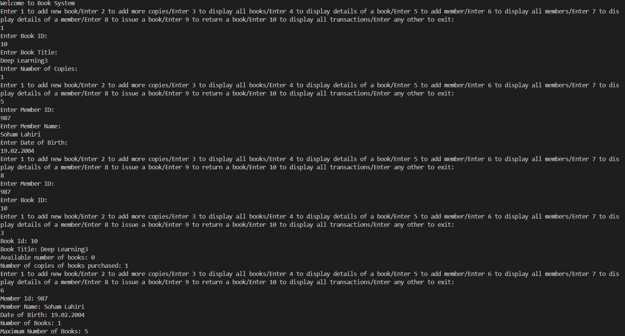

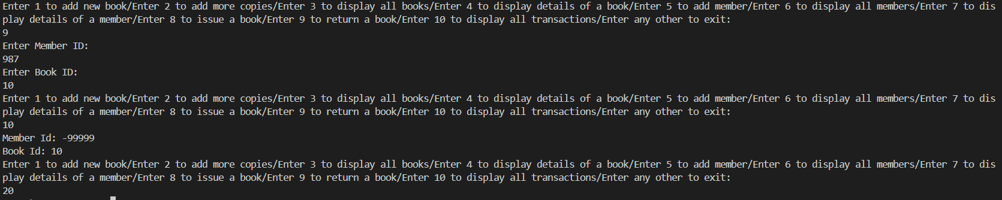
Question 4. Consider the packages designed in previous question. Design an interface to ensure that the library management must have the option i) add book ii) search book iii) view all book iv) add member v) search a member vii) view all members viii) issue book ix) return book.
Explanation:
LibraryManagement interface:
addBook, searchBook, viewAllBooks, addMember, searchMember, viewAllMembers, issueBook, and returnBook are method signatures, specifying what functionality a library management system should have.
default keyword before the method indicates that these methods have default implementations. This means that if a class implementing LibraryManagement does not override these methods, the default implementation provided in the interface will be used.
These methods are essential operations for managing a library: adding books and members, searching for books and members, viewing all books and members, issuing books to members, and returning books.
Code:
BookList package:
package BookList;

import java.util.ArrayList;
class BookInfo
{
private long bookId;
private String booktitle;
private int avail;
private int numberofbooks;

void setdata(String t,long Id,int n)
{
booktitle=t;
bookId=Id;
avail=n;
numberofbooks=n;
}
void displayinfo()
{
System.out.println("Book Id: "+bookId);
System.out.println("Book Title: "+booktitle);
System.out.println("Available number of books: "+avail);
System.out.println("Number of copies of books purchased: "+numberofbooks);
}
void issuebook()
{
avail--;
}
void returnbook()
{
avail++;
}
int checkeligible()
{
if(avail>0)
return 1;
else
return 0;
}
long getbookId()
{
return bookId;
}
void changenumberofbooks(int n)
{
numberofbooks+=n;
avail+=n;
}
}

public class BookInfoList
{
ArrayList<BookInfo> books=new ArrayList<BookInfo>();
public int checkbookunique(long id)
{
for(int i=0;i<books.size();i++)
{
if(id==books.get(i).getbookId())
return i;
}
return -1;
}

public void addBook(String t,long Id,int n)
{
BookInfo book=new BookInfo();
book.setdata(t,Id,n);
books.add(book);
}
public void displaybooks()
{
for(int i=0;i<books.size();i++)
{
books.get(i).displayinfo();
}
}
public void addbookcopies(long id,int n)
{
for(int i=0;i<books.size();i++)
{
if(id==books.get(i).getbookId())
books.get(i).changenumberofbooks(n);
}
}
public void displaypbook(long id)
{
for(int i=0;i<books.size();i++)
{
if(id==books.get(i).getbookId())
{
books.get(i).displayinfo();
}
}
}
public void issueBookl(long id)
{
for(int i=0;i<books.size();i++)
{
if(id==books.get(i).getbookId())
{
books.get(i).issuebook();;
}
}
}
public void returnBookl(long id)
{
for(int i=0;i<books.size();i++)
{
if(id==books.get(i).getbookId())
{
books.get(i).returnbook();
}
}
}
public int checkbookeligible(long id)
{
for(int i=0;i<books.size();i++)
{
if(id==books.get(i).getbookId())
{
return books.get(i).checkeligible();
}
}
return 0;
}
}

MemberList Package:
package MemberList;
import java.util.ArrayList;
class MemberInfo
{
private long memberId;
private String membername;
private String dateofbirth;
private int numberofbooks;
final private int limit=5;

void setdata(String name, String dob,long id)
{
membername=name;
dateofbirth=dob;
memberId=id;
numberofbooks=0;
}
void displayinfo()
{
System.out.println("Member Id: "+memberId);
System.out.println("Member Name: "+membername);
System.out.println("Date of Birth: "+dateofbirth);
System.out.println("Number of Books: "+numberofbooks);
System.out.println("Maximum Number of Books: "+limit);
}
void addbook()
{
numberofbooks++;
}
void removebook()
{
numberofbooks--;
}
int checkeligible()
{
if(numberofbooks<limit)
return 1;
else
return 0;
}
long getmemberId()
{
return memberId;
}
}

public class MemberInfoList
{
ArrayList<MemberInfo> members=new ArrayList<MemberInfo>();

public int checkmemberunique(long id)
{
for(int i=0;i<members.size();i++)
{
if(id==members.get(i).getmemberId())
{
return i;
}
}
return -1;
}
public void addmember(String name, String dob,long id)
{
MemberInfo member=new MemberInfo();
member.setdata(name,dob,id);
members.add(member);
}
public void displaymembers()
{
for(int i=0;i<members.size();i++)
{
members.get(i).displayinfo();
}
}
public void displaymember(long mid)
{
for(int i=0;i<members.size();i++)
{
if(mid==members.get(i).getmemberId())
{
members.get(i).displayinfo();
}
}
}
public void issuebookmember(long mid)
{
for(int i=0;i<members.size();i++)
{
if(mid==members.get(i).getmemberId())
{
members.get(i).addbook();
}
}
}
public void returnbookmember(long mid)
{
for(int i=0;i<members.size();i++)
{
if(mid==members.get(i).getmemberId())
{
members.get(i).removebook();
}
}
}
public int checkeligiblemember(long mid)
{
for(int i=0;i<members.size();i++)
{
if(mid==members.get(i).getmemberId())
{
return members.get(i).checkeligible();
}
}
return 0;
}
}

TransactionList Package:

package TransactionList;
import java.util.ArrayList;

class TransactionInfo
{
private long memberId;
private long bookId;
void setdata(long bid,long mid)
{
bookId=bid;
memberId=mid;
}
void displayinfo()
{
System.out.println("Member Id: " + memberId);
System.out.println("Book Id: " + bookId);
}
long getbookId()
{
return bookId;
}
long getmemberId()
{
return memberId;
}
void returnbookmember()
{
memberId = -99999;
}
}

public class TransactionInfoList
{
ArrayList<TransactionInfo> transactions=new ArrayList<TransactionInfo>();

public int checkmemberbookunique(long mid,long bid)
{
for(int i=0;i<transactions.size();i++)
{
if(mid==transactions.get(i).getmemberId() && bid==transactions.get(i).getbookId())
{
return i;
}
}
return -1;
}
public void addtransaction(long bid, long mid)
{
TransactionInfo transaction=new TransactionInfo();
transaction.setdata(bid,mid);
transactions.add(transaction);
}
public void displaytransactions()
{
for(int i=0;i<transactions.size();i++)
{
transactions.get(i).displayinfo();
}
}
public void removetransactions(long mid,long bid)
{
int index=checkmemberbookunique(mid,bid);
if(index!=-1)
{
transactions.get(index).returnbookmember();
}
}
}
Main Program:
import java.util.Scanner;
import BookList.BookInfoList;
import MemberList.MemberInfoList;
import TransactionList.TransactionInfoList;

interface LibraryManagement {
// Add a new book to the library
void addBook(String title, long bookId, int numberOfCopies);

// Search for a book by its ID or title
void searchBook(long bookId);

// View all books in the library
void viewAllBooks();

// Add a new member to the library
void addMember(String memberName, String dateOfBirth, long memberId);

// Search for a member by their ID
void searchMember(long memberId);

// View all members in the library
void viewAllMembers();

// Issue a book to a member
void issueBook(long memberId, long bookId);

// Return a book issued by a member
void returnBook(long memberId, long bookId);
}

class BookSystem implements LibraryManagement {
private BookInfoList bookList = new BookInfoList();
private MemberInfoList memberList = new MemberInfoList();
private TransactionInfoList transactionList = new TransactionInfoList();

@Override
public void addBook(String title, long bookId, int numberOfCopies) {
bookList.addBook(title, bookId, numberOfCopies);
}

@Override
public void searchBook(long bookId) {
bookList.displaypbook(bookId);
}

@Override
public void viewAllBooks() {
bookList.displaybooks();
}

@Override
public void addMember(String memberName, String dateOfBirth, long memberId) {
memberList.addmember(memberName, dateOfBirth, memberId);
}

@Override
public void searchMember(long memberId) {
memberList.displaymember(memberId);
}

@Override
public void viewAllMembers() {
memberList.displaymembers();
}

@Override
public void issueBook(long memberId, long bookId) {
if (memberList.checkmemberunique(memberId) != -1 && bookList.checkbookunique(bookId) != -1) {
if (memberList.checkeligiblemember(memberId) == 1 && bookList.checkbookeligible(bookId) == 1) {
transactionList.addtransaction(bookId, memberId);
bookList.issueBookl(bookId);
memberList.issuebookmember(memberId);
} else {
System.out.println("Member already has maximum number of books or no book copies available.");
}
} else {
System.out.println("Member ID or Book ID does not exist.");
}
}

@Override
public void returnBook(long memberId, long bookId) {
if (memberList.checkmemberunique(memberId) != -1 && bookList.checkbookunique(bookId) != -1) {
if (transactionList.checkmemberbookunique(memberId, bookId) != -1) {
transactionList.removetransactions(memberId, bookId);
bookList.returnBookl(bookId);
memberList.returnbookmember(memberId);
} else {
System.out.println("Book not issued to this member.");
}
} else {
System.out.println("Member ID or Book ID does not exist.");
}
}

public static void main(String[] args) {
BookSystem bs = new BookSystem();
Scanner sc = new Scanner(System.in);
int ch;

while (true) {
System.out.println("Enter 1 to add new book/Enter 2 to search book/Enter 3 to view all books/");
System.out.println("Enter 4 to add new member/Enter 5 to search member/Enter 6 to view all members/");
System.out.println("Enter 7 to issue book/Enter 8 to return book/Enter any other number to exit: ");
ch = sc.nextInt();
sc.nextLine();
if (ch == 1) {
System.out.println("Enter Book Title: ");
String title = sc.nextLine();
System.out.println("Enter Book ID: ");
long bookId = sc.nextLong();
sc.nextLine();
System.out.println("Enter Number of Copies: ");
int numberOfCopies = sc.nextInt();
sc.nextLine();
bs.addBook(title, bookId, numberOfCopies);
} else if (ch == 2) {
System.out.println("Enter Book ID: ");
long bookId = sc.nextLong();
sc.nextLine();
bs.searchBook(bookId);
} else if (ch == 3) {
bs.viewAllBooks();
} else if (ch == 4) {
System.out.println("Enter Member Name: ");
String memberName = sc.nextLine();
System.out.println("Enter Date of Birth: ");
String dateOfBirth = sc.nextLine();
System.out.println("Enter Member ID: ");
long memberId = sc.nextLong();
sc.nextLine();
bs.addMember(memberName, dateOfBirth, memberId);
} else if (ch == 5) {
System.out.println("Enter Member ID: ");
long memberId = sc.nextLong();
sc.nextLine();
bs.searchMember(memberId);
} else if (ch == 6) {
bs.viewAllMembers();
} else if (ch == 7) {
System.out.println("Enter Member ID: ");
long memberId = sc.nextLong();
sc.nextLine();
System.out.println("Enter Book ID: ");
long bookId = sc.nextLong();
sc.nextLine();
bs.issueBook(memberId, bookId);
} else if (ch == 8) {
System.out.println("Enter Member ID: ");
long memberId = sc.nextLong();
sc.nextLine();
System.out.println("Enter Book ID: ");
long bookId = sc.nextLong();
sc.nextLine();
bs.returnBook(memberId, bookId);
} else {
sc.close();
break;
}
}
}
}

Program Output:
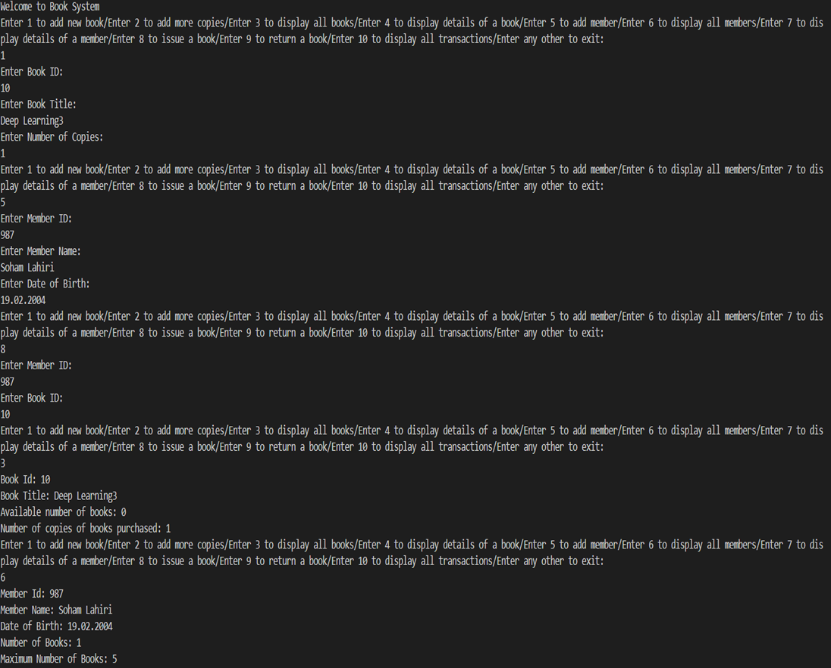

Question 5. Design a student class with roll, name and score. Support must be there to set the score. Score is non-negative and cannot exceed 100. For invalid score an exception has to be raised. User of set score method will decide about the measures to deal with the exception.
Explanation:
StudentInfo class:
This class represents information about a student, including their roll number, name, and score.
It has three private instance variables: roll (for roll number), name (for student name), and score (for student score).
The constructor StudentInfo(int a, String b) initializes the roll and name of the student. The score is initialized to 0.
The method set(float c) is used to set the score of the student. It checks whether the provided score is valid (between 0 and 100), and if it's not, it throws an ArithmeticException with the message "Invalid score".
The method display() simply prints out the student's roll number, name, and score.

Code:
import java.util.*;
class StudentInfo
{
private int roll;
private String name;
private float score;
StudentInfo(int a,String b)
{
roll=a;
name=b;
score=0;
}
void set(float c)
{
if(c<0||c>100)
throw new ArithmeticException("Invalid score");
else
score=c;
}
void display()
{
System.out.println("Roll No.: "+roll);
System.out.println("Name: "+name);
System.out.println("Score: "+score);
}
}
class ass2prog5 {
public static void main(String args[])
{
Scanner sc = new Scanner(System.in);
System.out.print("Enter roll number: ");
int r = sc.nextInt();
System.out.print("Enter name: ");
String na = sc.next();
System.out.print("Enter score: ");
float s = sc.nextFloat();
StudentInfo stu=new StudentInfo(r,na);
stu.set(s);
stu.display();
sc.close();
}
}
Program Output:
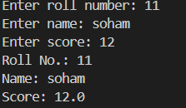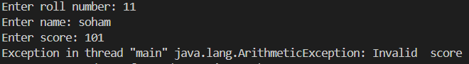

Question 6. Consider a wrapper class for a numeric basic type. Check the support for the following: conversion from i) basic type to object ii) object to basic type iii) basic type to String iv) String (holding numeric data) to numeric object v) object to String.
Explanation:
This program demonstrates different ways to perform conversions between basic data types, wrapper classes, and strings in Java.
Code:
class StringFuncts
{
public static void main(String args[])
{
int m=5;
Integer i = m; // basic to object

int n = 6;
n=i; //object to basic

String z=Integer.toString(m); //basic to string

String y="100";

Integer o=Integer.valueOf(y); //string to integer
String x=Integer.toString(i); //object to string
System.out.println(o);
}
}
Question 7. Take a String input that contains multiple words. Do the following: i) number of times ‘a’ appears ii) number of times “and” appears iii) whether it starts with “The” or not iv) put the String into an array of characters v) display the tokens in the String (tokens are the substrings separated by space or @ or .)
Explanation:
Input String: Prompt the user to enter a string.
Count 'a' occurrences: Iterate through the characters of the input string and count the occurrences of the character 'a'.
Check if starts with "The": Split the input string into words and check if the first word is "The".
Count "and" occurrences: Count the occurrences of the word "and" in the input string.
Print characters: Print each character of the input string separated by a space.
Tokenize the string: Split the input string into tokens using spaces, @ symbols, or periods as
Code:
import java.io.*;
class ass2prog7 {
public static void main(String args[])throws IOException
{
BufferedReader br=new BufferedReader(new InputStreamReader(System.in));
System.out.println("Enter the string:");
String s=br.readLine();s+=" ";
int n=s.length();
int i=0,c=0;
for(;i<n;i++)
{
if(s.charAt(i)=='a')
c++;
}
System.out.println("Number of a="+c);
c=0;
String[] str1 = s.split(" ");
if(str1[0].equals("The"))
System.out.println("It starts with The");
else
System.out.println("It does not start with The");
for(i=0;i<str1.length;i++)
{
if(str1[i].equals("and"))
c++;
}
System.out.println("Number of and="+c);
char[] ch=s.toCharArray();
for(i=0;i<ch.length;i++)
System.out.print(ch[i]+" ");
System.out.println();
String[] token=s.split("[ @.]");
System.out.println("Tokens in the string are :");
for(i=0;i<token.length;i++)
{
System.out.print(token[i]+",");
}
System.out.println();
}
}
Program Output:
